SSE2 Project Report
BoCoLa


Course: | SSE2 Spring 2010
Teacher: | Bent Brunn Kristensen
Faculty: | Faculty of Engineering at SDU
Due date: | Spring 2010

Group 1

Martin Moghadam
Kalle Grafström
Audrius Palisaitis
Robertas Jacauskas

Table of contents
1 - Introduction 3
2 – Language Definition 3
3 – Language Translation 3
4 – Runtime System Modification 3
5 – Example Experimentation 3
6 – Conclusion 3
7 – Appendix 3

1 - Introduction
In the course SSE2 we design, implement and experiment with a collaboration abstraction mechanism, BoCoLa, as a supplement to Java.

2 – Language Definition
In this section

3 – Language Translation
In this section

4 – Runtime System Modification
In this section

5 – Example Experimentation

In the BoCoLa program we write program syntax in the text file, as shown in table 5.1. There are two collaborations c1 and c2. Collaboration c1 synchronized, it was done using the special keyword sync.
Table 5.1: Translation from BoCoLa to Java
Language | Syntax
BoCoLa | collaboration c1  between 0, 1, 2  [  sync(move by 1, work by 2);  move by 0;  ]  collaboration c2  between 3,4,5  [  move by 5;  work by 3;  move by 4;  ]
Java | Collaborations[No] = new Collaboration();  {  Collaborations[No-1].include(new BotMethod.botMove(),Bot.bots[1],new BotMethod.botWork(),Bot.bots[2]);  Collaborations[No-1].include(new BotMethod.botMove(),Bot.bots[0]);  }  Collaborations[No]=new Collaboration();  {  Collaborations[No-1].include(new BotMethod.botMove(),Bot.bots[5]);  Collaborations[No-1].include(new BotMethod.botWork(),Bot.bots[3]);  Collaborations[No-1].include(new BotMethod.botMove(),Bot.bots[4]);  }

Then BoCola program text was saved in the text file and then executed the program. The program produced java code which can be used in a BotsSystem program. Java code from the BoCola program is shown in the table 5.1.The BoCoLa language is more structured and easier to read. To run the BotsSystem and test it, we need to copy java code into the system, compile and execute.
The collaborations are shown in figure 5.1. Green collaboration between bot 1 and bot 2 are synchronized. Synchronized collaboration takes more time to execute, because it is necessary to wait and then execution can continue.

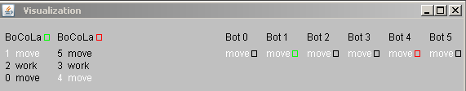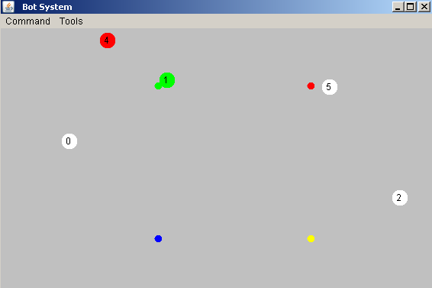
Figure 5.1: Bot System

By using the keyword sync it takes longer to execute, because of the wait. During synchronized bot execution no other bots execute. This guarantee right order of bots execution (move or/and work).

6 – Conclusion

7 – Appendix

The source code is included in the zip file and on the CD.

